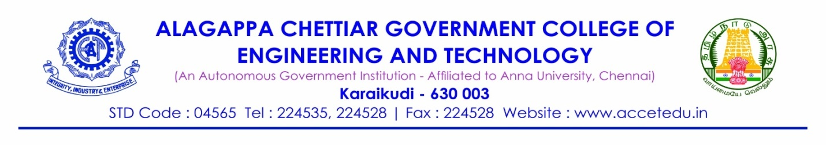
From
Deepak K, (91762112205)
Mech ‘A’ Batch,
ACGCET,
Karaikudi-630003
Mobile no:
Email id:

To
The Principal,
ACGCET,
Karaikudi-630003

Respected Sir,
Through Proper Channel
Sub: DOTE Internship 2023 - Permission – Reg.
I have been selected for the DOTE Internship 2023. I am very much interested in undergoing internship in the Neyveli Lignite Corporation limited, Neyveli from 18th June 2023 to 17th July 2023 for 25 days. It will be a great opportunity for me to learn a lot of new things. I will maintain complete discipline and self-mastery during the internship and also I will abide by the rules and regulations of the Industry. Kindly grant me permission to attend the Internship with OD as said above. The permission may please be granted.
Thank You
Yours faithfully,

(Deepak K, (91762112205))

Date:
Place: Karaikudi-630003

Submitted to the Principal

Faculty Advisor Prof & Head

